Species Distribution Models (SDMs) for rodent reservoirs of zoonotic New World Arenaviruses (NWA)

# Current species distribution maps

## Guanarito virus

Guanarito virus which causes Venezuelan Hemorrhagic fever in humans has two identified rodent reservoirs, namely, *Zygodontomys brevicauda* (short-tailed cane mouse) and *Sigmodon alstoni* (Alston’s cotton rat). Short-tailed cane mouse has a natural habitat in North-eastern part of the continent of South America (countries of Venezuela, Columbia, Guyana, Suriname, Northern part of Brazil and French Guiana; cite). It can inhabit a varied set of environments ranging from forested and dense grass areas to open agricultural lands but prefers sites close to water bodies. Adults weigh up to 60-80 grams with no sexual dimorphism and a litter size of 5-11 pups. These mice can survive from 1-5 years although detailed information on this is unavailable. Alston’s cotton rat is found naturally in the North-eastern part of the continent of South America (countries of Venezuela, Columbia, Suriname, Guyana, Brazil and French Guiana; cite). Its natural habitat is like other sigmodontid rodents that includes flatlands with shrubs, grass and open crop fields on low elevation lands. Most activity of the rats can be observed during daytime (diurnal). Unconfirmed reports of litter size include 3-7 pups.

Using historical occurrence data from GBIF (cite) for both rodent reservoirs of Guanarito virus, we converted the presence-only data to presence-absence data that was combined with the environmental and ecological raster data from various sources (see main text) to create species distribution maps. The SDM maps for current distribution can be seen in Figure S1 (a) and Figure S1 (b).

Z.brevicauda

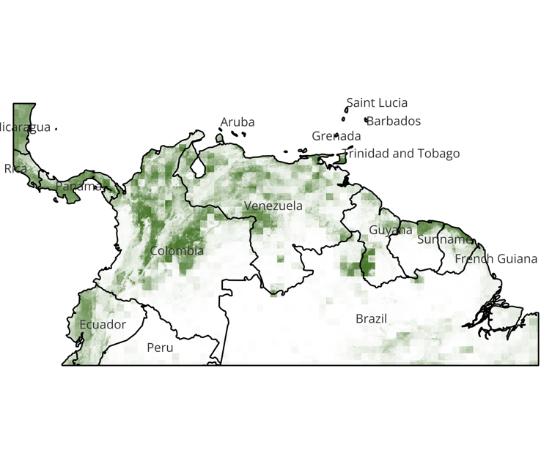

S.alstoni

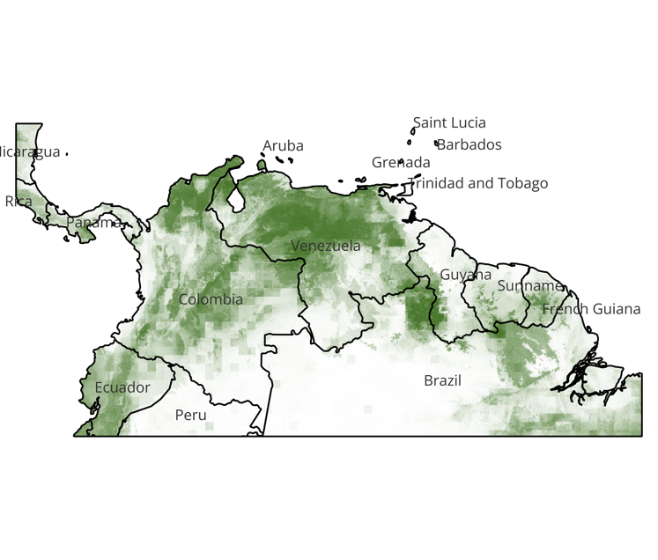

Figure S1. Current species distribution maps (from combination of outcomes from all four ensemble algorithms) for the two rodent reservoirs of Guanarito virus showing probabilities of presence (from 0 to 1).

### Z.brevicauda

Higher probabilities of presence was seen around the national parks in Columbia, Venezuela, Panama, Ecuador, Guyana and Suriname (Figure S1 a). The probabilities of presence were lower than threshold (p < 50%) near big metropolitan cities like Bogota, Medellin, Caracas, Georgetown, Quito in the corresponding countries. Only in Paramaribo and Panama City, the largest cities in Suriname and Panama respectively, higher probabilities of presence were estimated. This showed that the mouse species is generally present in forested and bordering grassland as well as cropped rural/ semi-urban areas. In general, the distribution patterns were most sensitive to seasonality and fluctuations in temperature, and cropland as well as other land use variables (Table S1).

### S.alstoni

The higher probabilities of presence for this species also somewhat coincided with the other rodent, *Z.brevicauda* near the central areas of Venezuela, center-east of Columbia, Boa vista border between Venezuela and northern Brazil, near all the national forests (Figure S1 b). However, the key difference was that higher probabilities were estimated for zones in and around the cities of Cartagena, Bogota in Columbia, Caracas, Maracaibo, Valencia in Venezuela which are some of the largest metropolitan areas. Whereas Georgetown in Guyana, Paramaribo in Suriname, Panama City in Panama displayed less than threshold presence probabilities. In general, the SDMs showed that the species presence is significantly higher in populated peri-urban and urban areas especially those with flatlands and presence of cropped or grassed areas surrounding cities. Like, *Z.brevicauda*, *S.alstoni* is also expected to be present near dense forested areas in the national or state park areas. In general, the species distribution was most sensitive to precipitation and temperature seasonality, especially during the dry season (Table S1).

## Machupo Virus

Machupo virus which causes Bolivian hemorrhagic fever in humans when spillover occurs, has one identified rodent reservoir species, namely, *Calomys callosus* (large vesper mouse). Large vesper mouse is a nocturnal mice species that is generalist in its habitat and has a wide distribution. Found primarily in Bolivia, it has also been reported in Argentina, Paraguay, and Brazil (cite). Due to their generalist habitation patterns, they can inhabit a variety of ecological niches. Litter sizes range between 3-5 pups and the adults who weigh between 30-50 grams, do not show sexual dimorphism. The SDM maps for current distribution of large vesper mouse can be seen in Figure S2.

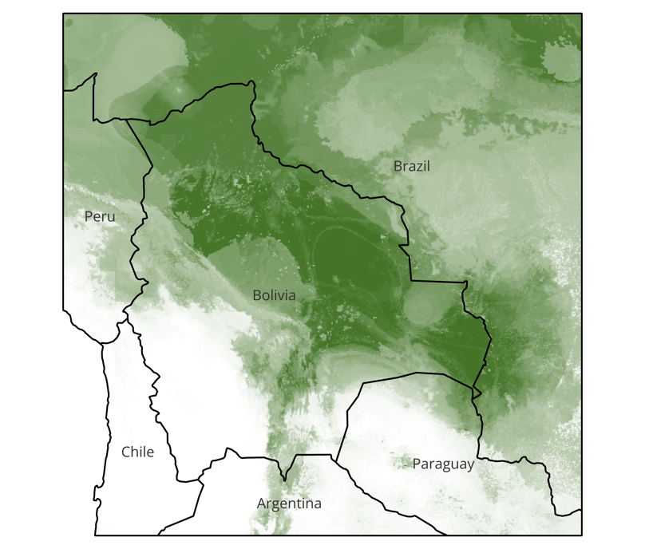

Figure S2. Current species distribution maps for the rodent reservoirs of Machupo virus showing probabilities of presence (from 0 to 1); combined outcomes from all four ensemble algorithms.

### Calomys callosus

Current SDMs of large vesper mouse show high probabilities of presence in the plains of Bolivia bordering the countries of Brazil, Argentina and Paraguay (Figure S2). Except for the Bolivian Andes regions, all regions show higher probabilities of presence than the threshold of 50%. The mouse species can be estimated to inhabit large diverse areas irrespective of rural or urban human settlements. The species presence, in general, was sensitive to features such as ranges of annual temperature and duration of day as well as total annual precipitation (Table S1).

# Junin Virus

Junin virus which causes Argentinian hemorrhagic fever in humans has three identified rodent reservoir species, namely, Calomys *musculinus* (Dryland Vesper Mouse), *Calomys laucha* (Small Vesper mouse) and *Oligoryzomys flavescens* (Yellow Pygmy Rice Rat).

Dryland Vesper mouse is historically found in Argentina, Bolivia, and Paraguay where it occupies a wide variety of habitats, like natural grasslands, shrub steppes, crop field borders, and human-disturbed environments such as wastelands, railroads, and urban garbage dumps (cite). As the common name suggests, its abundance changes seasonally, driven by natural climatic variations and land-use practices that affect resource availability.

*Calomys laucha* or Small Vesper mouse is historically found in the Chaco plains of Argentina, Bolivia, Paraguay, southeastern Brazil, small parts of Uruguay and Chile. Adults weigh approximately 13 grams. The mice prefer dryer, flat plains with crops or grass covered areas and where soil is sandy that helps them create burrows. Litter size can range from 5 to 10 pups per litter, and they follow a monogamous mating and nesting system (cite). Key ecological characteristics include seasonal changes to habitat selection where high vegetation areas are preferred in summer and winters are marked by more peri-domestic and open habitats.

Yellow pygmy rice rat is commonly found in Southern Brazil, Uruguay, Northern Argentina. These rats can inhabit arboreal, terrestrial be semi-aquatic areas and are typically spotted in pasture or croplands (cite). These rats are nocturnal in nature and do not move outside of natural home range. Very little is known about their reproductive behavior and unconfirmed reports include a litter size of 3-7 pups and seasonality in reproductive behavior. Adults can weigh around 40 grams.

The SDM maps for current distribution of the three rodent reservoirs for Junin virus can be seen in Figure S3 (a,b and c).

1. Calomys musculinus

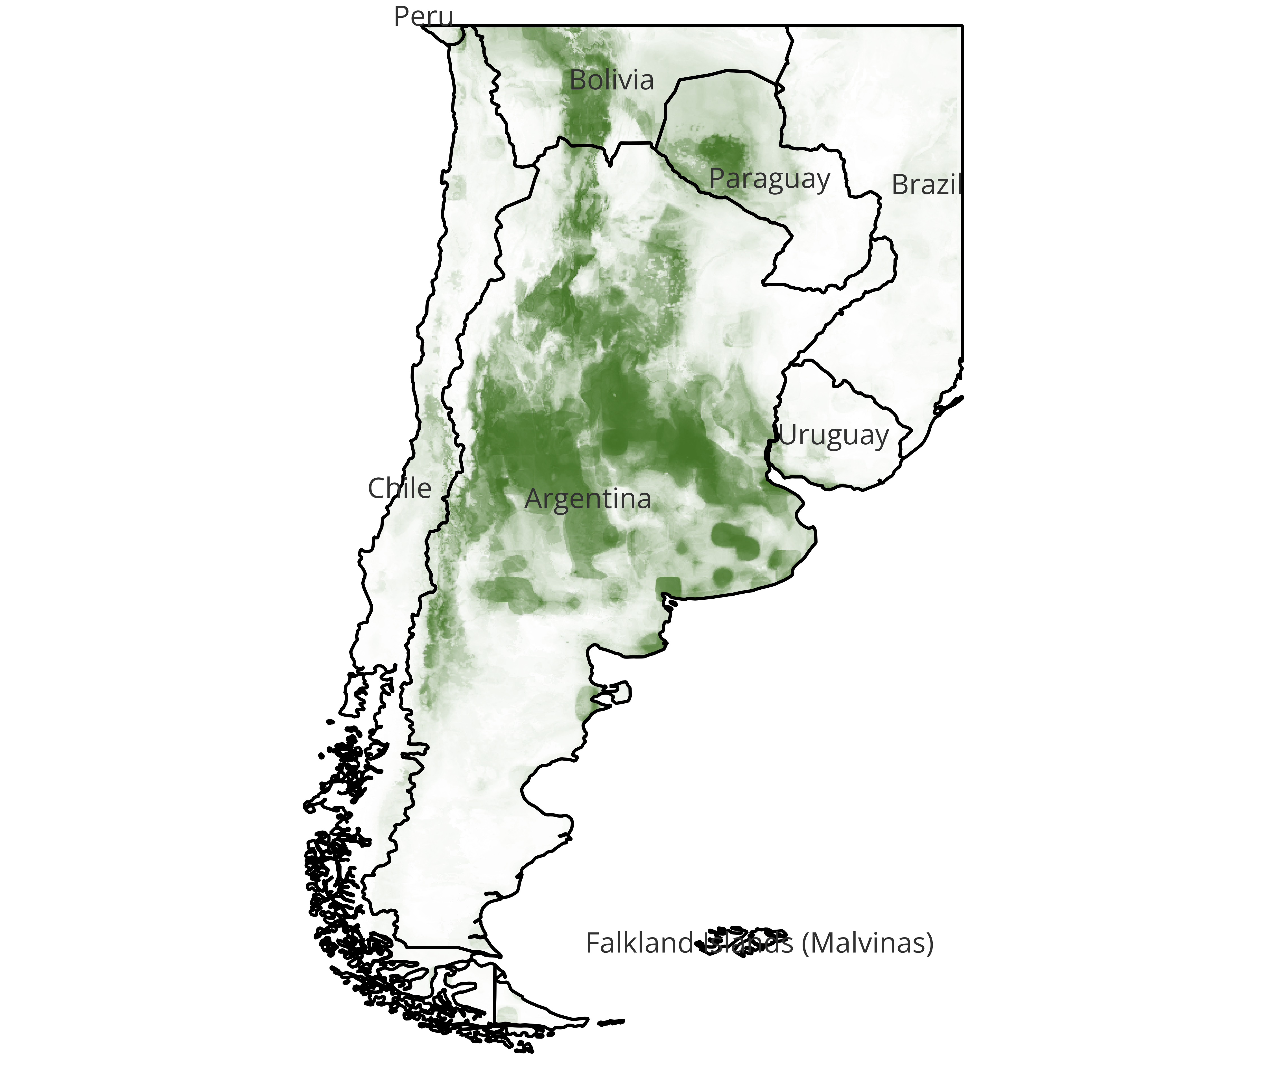

1. Calomys laucha

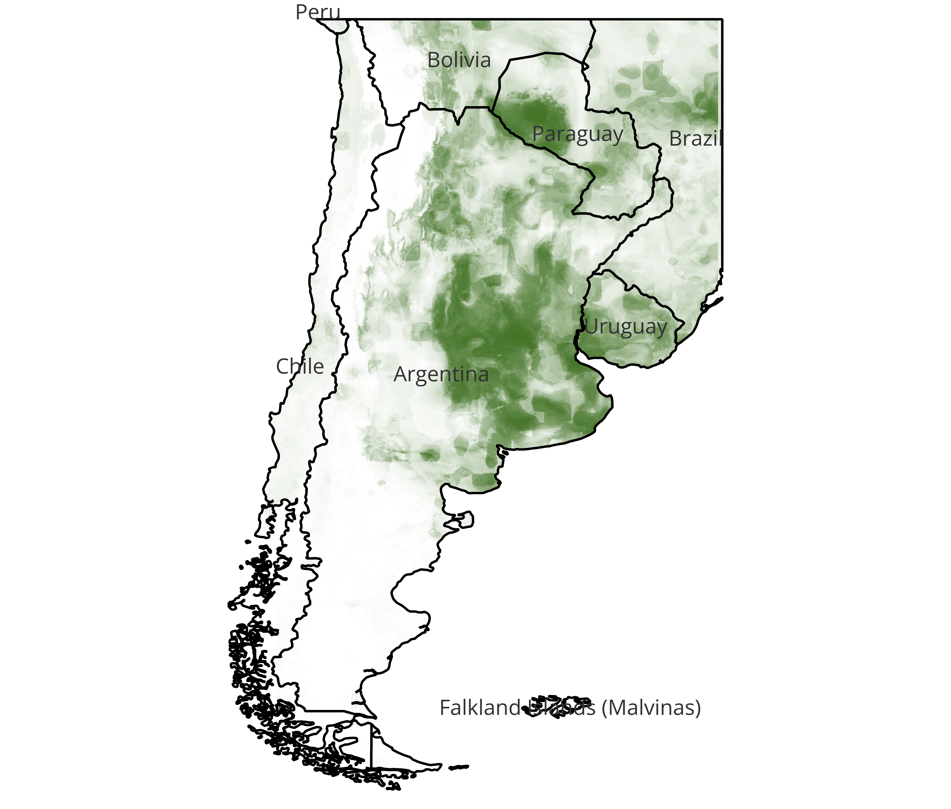

1. Oligoryzomys flavescens

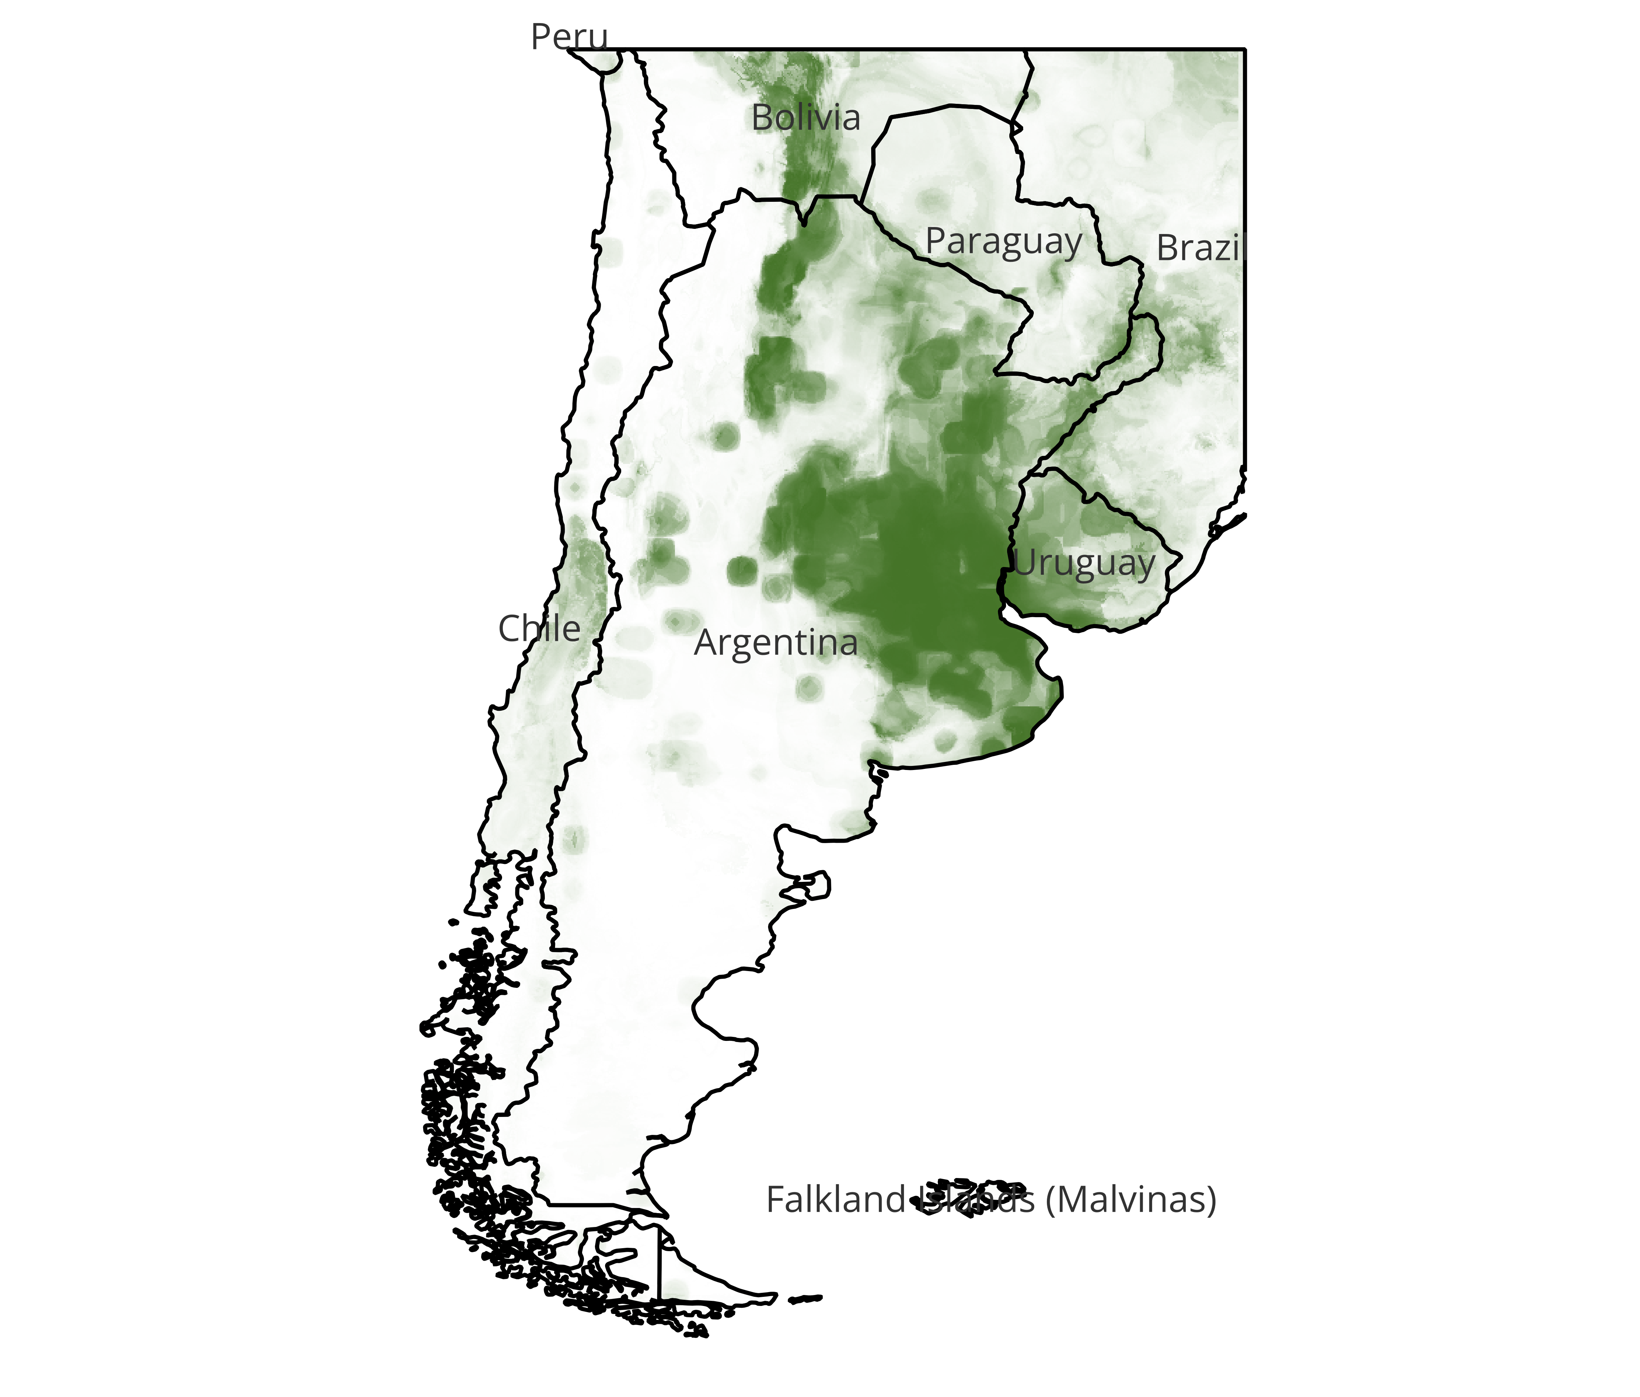

Figure S3. Current species distribution maps for the three rodent reservoirs of Junín virus showing probabilities of presence (from 0 to 1); combined outcomes from all four ensemble algorithms.

### Calomys musculinus

As seen in Figure S3 (a), higher probabilities of presence were estimated in the regions such as Pampas, Espinal, Monte de Llanuras y Mesetas, Chaco seco, Monte de Sierras y Bolsones, and Yungas which are situated in the basins of central Argentina. For details, see our other work (cite). The species distribution was mostly influenced by presence of urban land and total annual precipitation among other eco-environmental features (Table S1).

### Calomys laucha

The species distribution patterns were estimated much like those of C.musculinus (Figure S3 (a, b)). The key differences were that lower probabilities than threshold of 50% were estimated in the Andean mountainous region bordering Chile and Argentina. Also, much higher probabilities were observed around metropolitan cities on coast of Argentina including Buenos Aires. The species distribution was most sensitive to features such as cropland and maximum recorded temperature in the warmest month, in other words the intensity of summer was a key feature for species distribution in general (Table S1).

### Oligoryzomys flavescens

Compared to the other two reservoirs, the pygmy rat distribution patterns were slightly different in estimation. Highest probabilities were estimated in Cordoba, Entre Rios and Buenos Aires provinces in Argentina and coastal areas of Uruguay which surround the Rio de la Plata region at the confluence of Uruguay river and Parana river in the Pampa ecoregion (Figure S3 (c)).The species distribution was sensitive to features such as presence of crop or urban lands, total annual precipitation and precipitation during the warm period in general (Table S1).

## Important features for current species distribution maps

The variability in the species distribution patterns of all the rodent reservoirs of the three NWAs under study were marked by variability in the importances of eco-environmental features that were used to predict the species distribution maps. Table S1 shows the top most important features per the algorithm for all six of the rodent reservoirs of the three NWAs.

Table S1. Topmost important features for rodent reservoir species distribution models.

|  |  |  |  |
| --- | --- | --- | --- |
| Species | Algorithm | Top 5 selected (number of times selected in 100 simulations with Recursive Feature Elimination) | Top 5 feature importances (feature importance in mean reduction of impurity – 2 decimal points) |
| *Z.brevicauda* | RF | * DEM (92) * LUCrop (100) * LUOthr (100) * LUpast (100) * LUurbn (100) | * LUothr (0.13) * LUurbn (0.12) * LUcrop (0.12) * LUpast (0.09) * LUsecd (0.06) |
|  | ET | * Mean Diurnal Range (99) * LUother (100) * LUcrop (100) * LUpast (100) * LUsecd (100) | * LUothr (0.16) * LUcrop (0.11) * LUpast (0.1) * Precipitation Seasonality (0.06) |
|  | XGB | * Isothermality (94) * LUSecd (95) * LUurbn (95) * LUcrop (100) * LUothr (100) | * LUothr (0.18) * LUcrop (0.17) * LUurbn (0.07) * LUpast (0.06) * Isothermality (0.06) |
|  | LGBM | * Temperature Seasonality (93) * Isothermality (94) * NDVI (96) * LUcrop (97) * Precipitation Seasonality (98) | * Isothermality (0.08) * Temperature Seasonality (0.08) * NDVI (0.07) * LUcrop (0.07) * Mean Diurnal Range (0.07) |
| *S.alstoni* | RF | * Precipitation Seasonality (91) * Precipitation of Driest Month (93) * LUpast (97) * Temperature Seasonality (98) * Precipitation of Driest Quarter (100) | * Precipitation of Driest Quarter (0.1) * Temperature Seasonality (0.09) * Precipitation of Driest Month (0.08) * LUpast (0.08) * Precipitation Seasonality (0.08) |
|  | ET | * Temperature Seasonality (97) * LUpast (97) * Precipitation Seasonality (97) * Precipitation of Driest Month (98) * Precipitation of Driest Quarter (100) | * Precipitation Seasonality (0.08) * Precipitation of Driest Quarter (0.08) * LUpast (0.08) * Precipitation of Driest Month (0.08) * Temperature Seasonality (0.08) |
|  | XGB | * LUpast (78) * Isothermality (79) * LUurbn (86) * Precipitation of Driest Quarter (93) * Temperature Seasonality (97) | * Precipitation of Driest Quarter (0.16) * Temperature Seasonality (0.08) * Precipitation of Warmest Quarter (0.07) * LUpast (0.07) * LUurbn (0.07) |
|  | LGBM | * Precipitation of Wettest Month (81) * Precipitation of Warmest Quarter (81) * Mean Diurnal Range (82) * Temperature Seasonality (88) * LUurbn (96) | * NDVI (0.09) * LUurbn (0.09) * Temperature Seasonality (0.08) * Precipitation of Wettest Month (0.08) * Precipitation of Driest Quarter (0.07) |
| *C.callosus* | RF | * Annual Precipitation (96) * Mean Diurnal Range (99) * Precipitation of Wettest Month (100) * Precipitation of Wettest Quarter (100) * Temperature annual Range (100) | * Mean Diurnal Range (0.12) * Precipitation of Wettest Month (0.09) * Temperature Annual Range (0.09) * Precipitation of Wettest Quarter (0.08) * Min Temperature of Coldest Month (0.08) |
|  | ET | * Annual Precipitation (96) * Precipitation of Wettest Quarter (98) * Precipitation of Wettest Month (99) * Mean Diurnal Range (99) * Temperature Annual Range (100) | * Temperature Annual Range (0.11) * Mean Diurnal Range (0.09) * Precipitation of Wettest Month (0.07) * Annual Precipitation (0.07) * NDVI (0.07) |
|  | XGB | * Temperature Seasonality (81) * Precipitation of Wettest Quarter (82) * Mean Diurnal Range (86) * Precipitation of Wettest Month (87) * Temperature Annual Range (95) | * Mean Diurnal Range (0.2) * Precipitation of Wettest Quarter (0.11) * Precipitation of Wettest Month (0.09) * Temperature Annual Range (0.08) * Annual Mean Temperature (0.07) |
|  | LGBM | * Isothermality (88) * Mean Diurnal Range (89) * NDVI (93) * Temperature Seasonality (93) * Temperature Annual Range (96) | * NDVI (0.1) * Temperature Annual Range (0.08) * Temperature Seasonality (0.08) * Isothermality (0.08) * Annual Precipitation (0.07) |
| *C.musculinus* | RF | * Mean Temperature of Wettest Quarter (92) * Temperature Annual Range (95) * Annual Precipitation (100) * LUurbn (100) * Mean Diurnal Range (100) | * LUurbn (0.11) * Mean Diurnal Range (0.09) * Annual Precipitation (0.08) * Precipitation of Wettest Quarter (0.07) * Temperature Annual Range (0.07) |
|  | ET | * Temperature Annual Range (93) * LUpast (94) * Mean Diurnal Range (96) * Mean Temperature of Wettest Quarter (97) * Annual Precipitation (98) | * Mean Diurnal Range (0.07) * LUpast (0.07) * Annual Precipitation (0.07) * Mean Temperature of Wettest Quarter (0.07) * Temperature Annual Range (0.07) |
|  | XGB | * LUpast (82) * Precipitation Seasonality (85) * Mean Diurnal Range (96) * Annual Precipitation (97) * LUurbn (99) | * Annual Precipitation (0.11) * LUurbn (0.1) * Mean Diurnal Range (0.09) * Temperature Annual Range (0.08) * Precipitation Seasonality (0.07) |
|  | LGBM | * Max Temperature of Warmest Month (87) * LUpast (92) * Mean Diurnal Range (96) * LUSecd (96) * LUurbn (100) | * LUurbn (0.11) * Mean Diurnal Range (0.1) * LUsecd (0.08) * LUpast (0.08) * Max Temperature of Warmest Month (0.07) |
| *C.laucha* | RF | * Max Temperature of Warmest Month (89) * Annual Precipitation (90) * Mean Temperature of Wettest Quarter (95) * Temperature Annual Range (98) * LUcrop (100) | * LUcrop (0.12) * Temperature Annual Range (0.08) * Mean Temperature of Wettest Quarter (0.07) * Max Temperature of Warmest Month (0.07) * Annual Precipitation (0.07) |
|  | ET | * Max Temperature of Warmest Month (92) * Annual Precipitation (93) * Temperature Annual Range (94) * Mean Temperature of Wettest Quarter (99) * LUcrop (100) | * LUcrop (0.1) * Mean Temperature of Wettest Quarter (0.08) * Temperature Annual Range (0.07) * Max Temperature of Warmest Month (0.07) * Mean Temperature of Warmest Quarter (0.07) |
|  | XGB | * Temperature Annual Range (82) * Max Temperature of Warmest Month (82) * LUurbn (89) * Annual Precipitation (92) * LUcrop (100) | * LUcrop (0.15) * Annual Precipitation (0.08) * LUothr (0.08) * Precipitation of Coldest Quarter (0.07) * LUpast (0.07) |
|  | LGBM | * LUsecd (86) * LUcrop (89) * LUothr (90) * LUpast (91) * LUurbn (99) | * LUurbn (0.12) * LUcrop (0.08) * LUsecd (0.08) * Lupast (0.08) * Luothr (0.08) |
| *O.flavescens* | RF | * Mean Temperature of Wettest Quarter (88) * Precipitation of Warmest Quarter (98) * Annual Precipitation (98) * LUurbn (100) * LUcrop (100) | * LUurbn (0.16) * LUcrop (0.09) * Precipitation of Warmest Quarter (0.07) * Precipitation in wettest Month (0.07) * Annual Precipitation (0.07) |
|  | ET | * Precipitation of Warmest Quarter (93) * Annual Precipitation (94) * LUurbn (96) * Mean Temperature of Wettest Quarter (98) * LUcrop (100) | * LUcrop (0.09) * Mean Temperature of Wettest Quarter (0.08) * Annual Precipitation (0.08) * Precipitation of Warmest Quarter (0.07) * Mean Temperature of Coldest Quarter (0.07) |
|  | XGB | * LUcrop (87) * Max Temperature of Warmest Month (87) * Annual Precipitation (92) * Precipitation of Warmest Quarter (92) * LUurbn (100) | * LUurbn (0.2) * Annual Precipitation (0.1) * Precipitation of Warmest Quarter (0.09) * Precipitation of Wettest Month (0.08) * Precipitation of Coldest Quarter (0.05) |
|  | LGBM | * Annual Precipitation (88) * Max Temperature of Warmest Month (90) * LUsecd (91) * LUcrop (94) * LUurbn (100) | * LUurbn (0.13) * LUcrop (0.08) * Max Temperature of Warmest Month (0.08) * LUsecd (0.07) * Annual Precipitation (0.07) |

Note: Abbreviations: RF: random forest algorithm, ET: Extra Trees algorithm, XGB: eXtra Gradient Boost, LGBM: Light Gradient Boost Model, LUcrop: Land use – cropland, LUurban: Land use – urban land, LUpast: Land use – Pasture land, LUsecd: Land use – secondary/ non-agricultural/ forested land, LUothr: Land use – Other land use, NDVI: Normalized Difference Vegetation Index.

In contrast to Table S1, the Figure S4 (a) shows the feature importance of all the 26 eco-environmental features for all six rodent reservoirs distributed over the 4 algorithms of 3 NWAs.

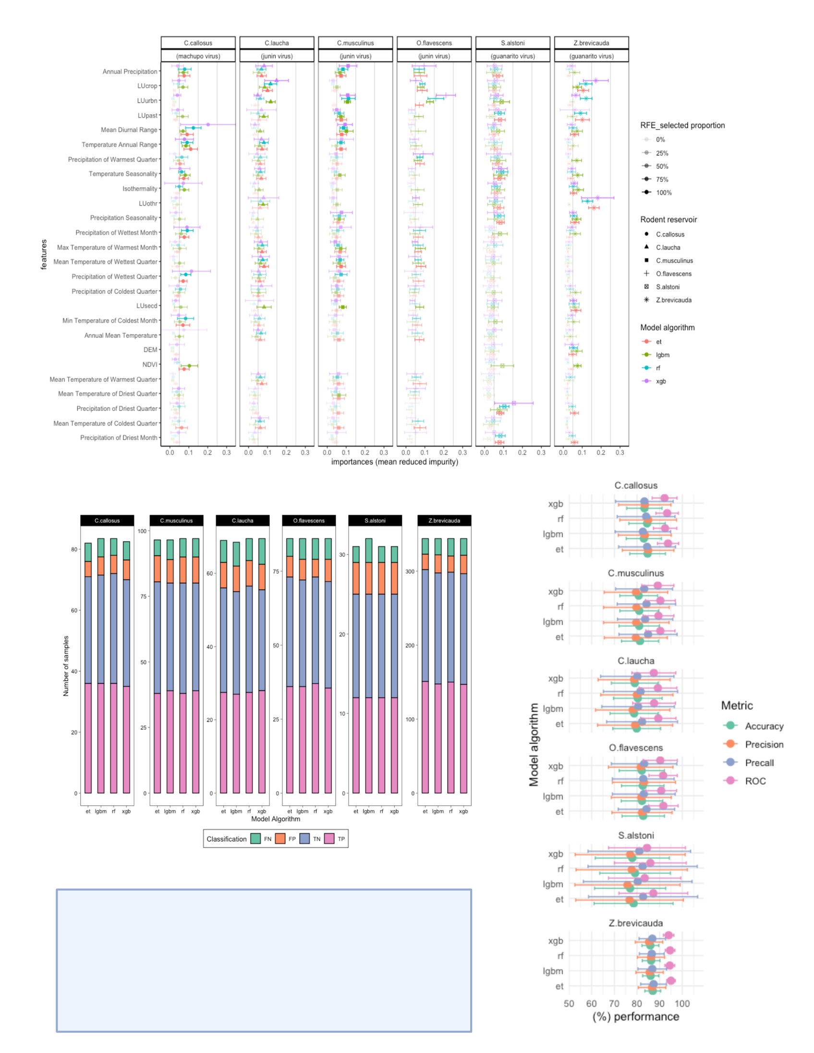

Figure S4. (a) Feature importances of all 26 raster features based on mean reduced impurity from the four ensemble algorithms along classified based on number of times the feature was selected in Recursive Feature Elimination (RFE) technique. (b) Performance metrics for all six rodent reservoirs for four algorithms (RF, ET, XGB and LGBM) along with the (c) confusion matrix for True Positives (TP), True Negatives (TN), False Positives (FP) and False Negatives (FN)

## Model performance metrics

Depending on the variability in the eco-environmental raster features, the four modeling algorithms, namely, Random Forest (RF), Extra Trees (ET), Extra Gradient Boost (XGB) and Light Gradient Boosting Model (LGBM) performed adequately. In general, the 5-fold cross validation accuracy ranged between 77% and 87%, the Area Under the ROC Curve (AUC-ROC) was between 83% and 95% and the recall for positive responses (presence of species in the given geographical context) was between 80% and 87%. Similarly, the F1 scores on the test data which was 25% of the original data (75% being the training and validation set) was 77-88% with a 12-20% false response rate. Figure S4 (b and c) shows more detailed description of these metrics distributed across the six rodent reservoir species.

# Projected Future species distribution maps

Using CMIP6 models of climate change scenarios, we projected the distribution of the rodent reservoirs of Guanarito virus, Machupo virus and Junin virus in years 2041 to 2060. We selected two contrasting scenarios of SSP 2.45 (cite) or moderate climate change scenario and SSP 5.85 (cite) or extreme climate change scenario for this SDM projection. Using the same trained models of current SDMs, we imputed the probabilities for presence of the species in all of the geographical locations in the current expanse of habitation for the rodent species as observed in the GBIF occurrence data. We also identified the difference in probabilities of presence between the current SDMs and the projected future CMIP6 SDMs and mapped them in Figure S5. 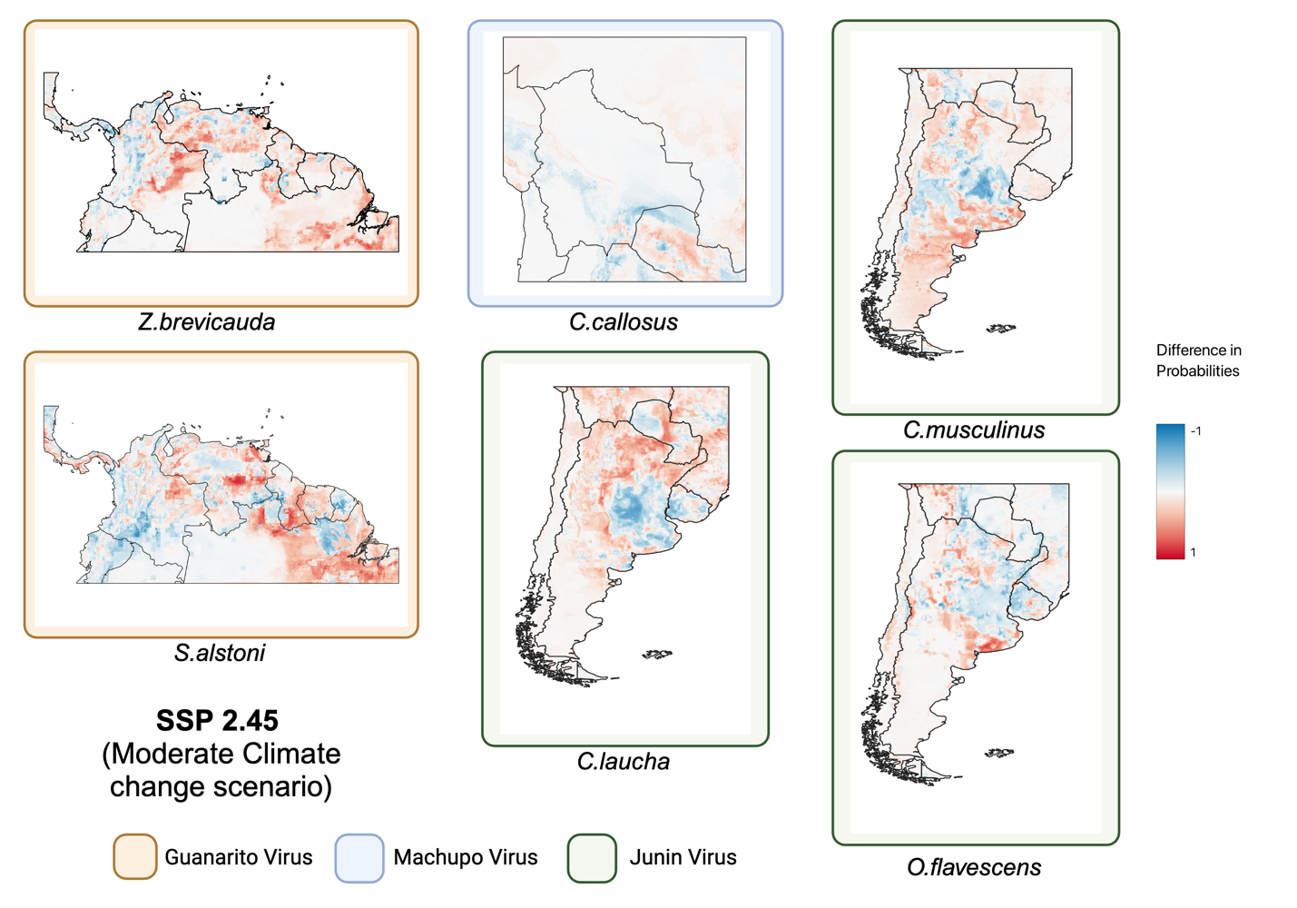

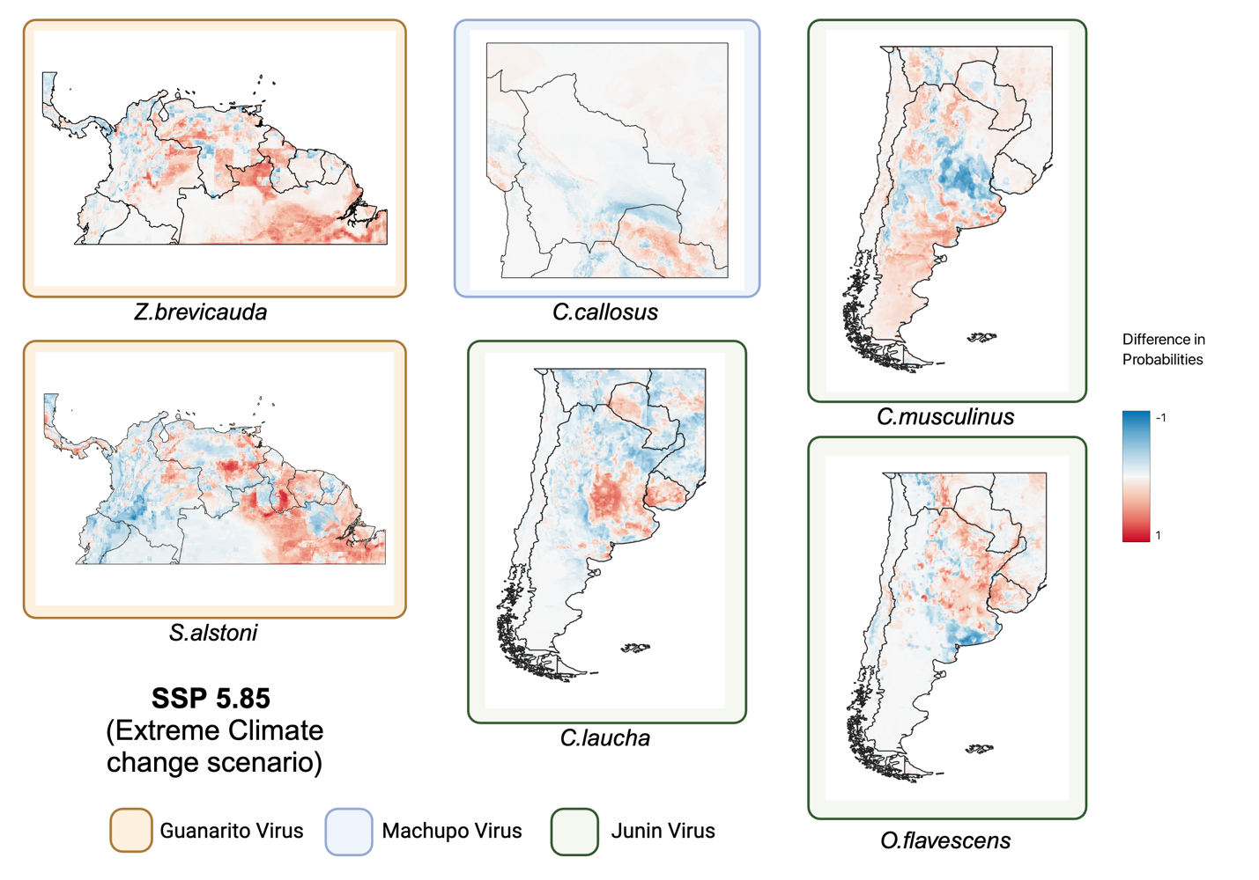

Figure S5. Difference in probabilities (delta maps) between current and projected species distribution of the six rodent reservoir species.

In general, the projected SDMs had remarkably different probabilities of presence for the rodent species predicting a radical change in the habitat of the rodent reservoirs to be expected in the future. However, the differences in the probabilities of presence between the two CMIP6 scenarios, namely SSP 2.45 and SSP 5.85, were more subtle and hard to identify. Differences in probabilities of presence and distribution patterns of all six rodent reservoir species for NWAs is summarized in Table S2.

Table S2. Summary of delta maps (difference in probabilities of presence) for SSP 2.45 and SSP 5.85 compared to current species distribution maps (see Figures S1-S3).

|  |  |  |  |  |
| --- | --- | --- | --- | --- |
| **Virus** | **Species** | **CMIP6 Scenario** | **Increase in Probabilities** | **Decrease in Probabilities** |
| **Guanarito Virus** | *Z.brevicauda* | SSP 2.45 | Around rivers: Orinoco (Columbia), Branco (near Boa Vista), Amazon & tributaries (Xingu) in Brazil | Columbian Andes (north and south of Medellin)  River Sipapo  River Orinoco (Venezuela)  Marahuaca National Park  Venezuela-Brazil border (Neblina National Park) |
|  |  | SSP 5.85 | Higher intensity around rivers Branco, Amazon (Boa Vista, Manaus, Santarem, Tucurui)  River Meta (Columbia), River Apure (Venezuela) | National Park Cnaruco-Capanoparo  River Sipapo  South of Las Vegas (Venezuela)  Venezuela-Brazil border (Neblina National Park) |
|  | *S.alstoni* | SSP 2.45 | East & west of Guri Reservoir (San Pedro Forest, La Paragua)  River Cano Manamo (up to Gulf of Paria)  River Meta (Columbia-Venezuela border)  River Magdalena (north Columbia)  Northern border of Brazil (Guyana, Serra do Sol, Roraima)  South of Amazon Delta (Itacotiara to Mapaca) | Venezuela-Brazil border (Canaima National Park, Santa Inez)  River Caguan & tributaries (south-west Columbia)  Monkey Mountain & Karisparu (Guyana)  Central Suriname, French Guiana  Northern Brazil (Suriname & French Guiana border) |
|  |  | SSP 5.85 | Similar to SSP 2.45 with more intensity | Similar to SSP 2.45 with more intensity |
| **Machupo Virus** | *C.callosus* | SSP 2.45 | West of Paraguay River (Gran Chaco basin, north of Concepcion)  River Pilcomayo (Bolivia-Argentina border)  Campo Grande (Brazil)  South of Salinas and Aguada Blanca (Peru) | West of Filadelfia (Paraguay)  Kaa Iya National Park (north Paraguay-Bolivia border)  West of River Bermejo (Argentina-Bolivia border) |
|  |  | SSP 5.85 | Tacna (Peru-Chile border)  East of River Cuiaba (Brazil) | Similar to SSP 2.45 |
| **Junin Virus** | *C.musculinus* | SSP 2.45 | <need to compare it with Nuri’s work> | <need to compare it with Nuri’s work> |
|  |  | SSP 5.85 | <need to compare it with Nuri’s work> | <need to compare it with Nuri’s work> |
|  | *C.laucha* | SSP 2.45 | Gran Chaco plains (east of Andes in Argentina)  Paraguay (northern border with Brazil)  Rio Negro Province (Argentina)  Southern Bolivia-Argentina border (River Picomayo, Villa Montes, Camiri)  Maringa (Brazil)  Mato Grosso do Sul (Brazil) | Around Santa Cruz de la Sierra  Cordoba plains (Argentina)  around city of Junin  Mar del Plata (Atlantic coast)  Pampas (Argentina)  around Buenos Aires metropolis  Argentina-Uruguay border (Uruguay river)  Eastern Uruguay (Treinta y Tres) |
|  |  | SSP 5.85 | Similar to SSP 2.45 | Similar to SSP 2.45 but more intensity around Inao National Park (Bolivia)  Tri-border area (Bolivia, Argentina, Paraguay) |
|  | *O.flavescens* | SSP 2.45 | Sporadic pockets in central plains (Cordoba, southern Buenos Aires)  Bolivian Andes (near Oruro) | Eastern Argentina (borders with Paraguay, Brazil, Uruguay)  East of Andes (Vallegrande to Villa Montes) |
|  |  | SSP 5.85 | More pronounced in Central Chile (Talca to Temuco) | Borders (Paraguay, Brazil, Argentina near Cuidad del Este) |